**ER Diagram:**

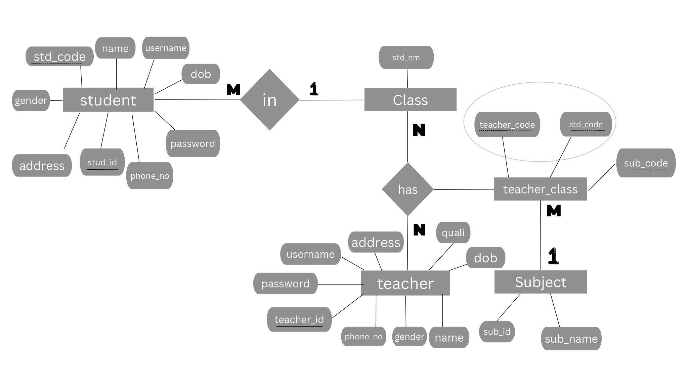

**Query’s:**

**Table creation:**

1. mysql> create table student (stud_id int primSelect stud_id,name,gen,std_code,dob,phone_no from Student order by(stud_id)desc limit 5ary key,name varchar(20) not null,gen char not null,std_code varchar(10) not null,dob date not null,phone_no bigint(10) not null,address varchar (60) not null,username varchar(20),password varchar(15));
2. mysql> create table class (std_id varchar(10) primary key);
3. mysql> create table teacher (teacher_id int(5) primary key,name varchar(20) not null,gen char not null,quali varchar(10) not null,dob date not null,phone_no bigint(10) not null unique,address varchar(60) not null,username varchar(20) not null,password varchar(15) not null);
4. mysql> create table subject(sub_id int(5) primary key,sub_name varchar(20) not null);
5. mysql>create table teach_class(std_code varchar(10) ,teacher_code int ,sub_code int)

**Relationship:**

1. mysql> alter table student add foreign key(std_code) references class(std_id);
2. mysql> alter table teach_class add foreign key(teacher_code) references teacher(teacher_id);
3. mysql> alter table teach_class add foreign key(std_code) references class(std_id);
4. mysql> alter table teach_class add foreign key(sub_code) references subject(sub_id);
5. mysql> alter table teach_class add primary key(teacher_code,std_code);

**Data fetching :**

1. mysql> select class.std_id,subject.sub_name from teacher,class,teach_class,subject where teacher.teacher_id=teach_class.teacher_code and class.std_id=teach_class.std_code and subject.sub_id=teach_class.sub_code and teacher.teacher_id=502;
2. SELECT teacher.name, subject.sub_name FROM teacher, class , teach_class , subject where teacher_id=teacher_code and sub_id=sub_code and std_id=std_code and std_id="6th std";
3. update student set username=%s,password=%s where stud_id=%s
4. Select stud_id,name,gen,std_code,dob,phone_no from Student order by(stud_id)desc limit 5

etc.